VLSI Design Internship – Task 3 Report
Topic: Verilog RTL Design of Sequential Circuits and Flip-Flops
Name: HARSH SAXENA
College: USICT (GGSIPU)

D Flip-Flop simulation output
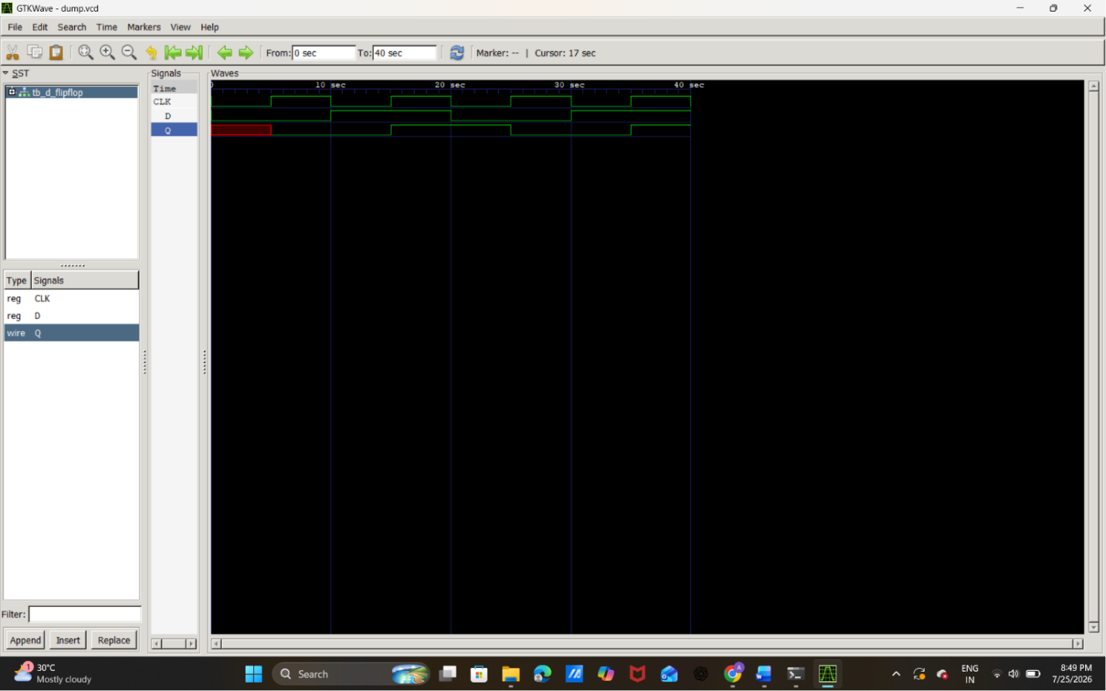

CLK is toggling every 5 time units.
D changes at 10, 20, 30, and 40 time units.
Q updates only on the positive (rising) edge of the clock, which is the correct behavior of a D Flip-Flop.
The red section at the beginning of Q is normal—it indicates Q is unknown (X) before the first rising clock edge because it hasn't been initialized yet.
D Flip-Flop Simulation Truth Table (According to Waveform)
Time (ns) | CLK ↑ | D | Q (Output)
0 | No | 0 | X (Unknown)
S5 | ↑ | 0 | 0
15 | ↑ | 1 | 1
25 | ↑ | 0 | 0
35 | ↑ | 1 | 1

J-K Flip-Flop simulation output

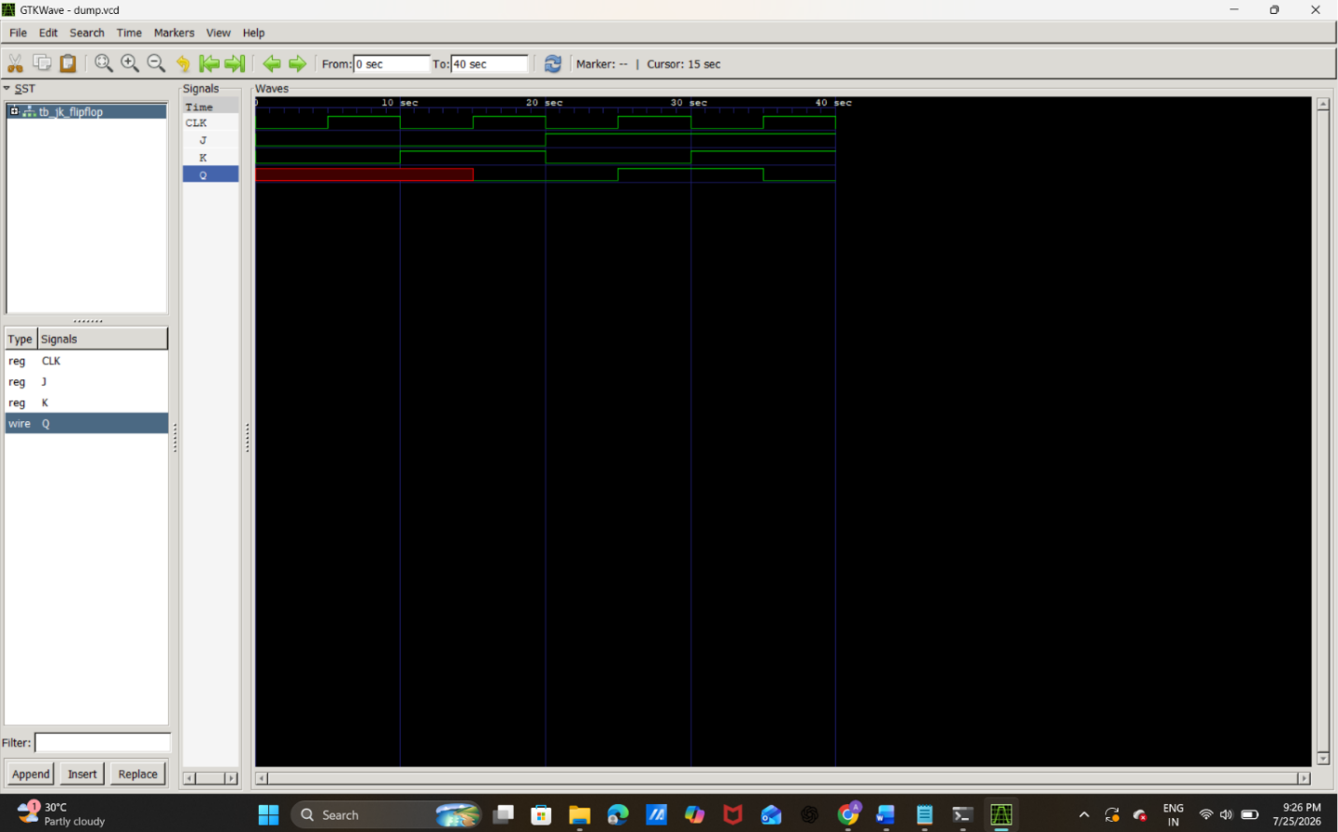
Signals
- CLK → Clock input
- J → J input
- K → K input
- Q → Output
The JK Flip-Flop changes its output only at the positive (rising) edge of the clock.
Waveform Explanation
Initial State (0–10 ns)
J = 0
K = 0
Q = X (Unknown)
The red portion of Q indicates an unknown value because the flip-flop has not yet received a rising clock edge.
At the first positive clock edge, since J = 0 and K = 0, the flip-flop is in the No Change condition. Because there was no previous valid output, Q remains unknown.
10–20 ns
J = 0
K = 1
This is the Reset condition.
At the next rising edge of the clock:
Q = 0
The output is reset to logic 0.

20–30 ns
J = 1
K = 0
This is the Set condition.
At the next positive clock edge:
Q = 1
The output becomes logic 1.

30–40 ns
J = 1
K = 1
This is the Toggle condition.
At the next rising edge:
Previous Q = 1
New Q = 0
The output toggles from 1 to 0.

JK Flip-Flop Truth Table
J | K | Operation | Next Q
0 | 0 | No Change | Previous Q
0 | 1 | Reset | 0
1 | 0 | Set | 1
1 | 1 | Toggle | Complement of Previous Q

JK Flip-Flop Simulation Truth Table
Time (ns) | CLK ↑ | J | K | Previous Q | New Q | Operation
5 | ↑ | 0 | 0 | X | X | No Change
15 | ↑ | 1 | 1 | X | Toggle (undefined initially)
25 | ↑ | 0 | 0 | 1 | 1 | No Change
35 | ↑ | 1 | 1 | 1 | 0 | Toggle

Q change only at the clock edge:
The JK Flip-Flop is positive edge-triggered, so it samples the values of J and K only when the clock changes from 0 to 1. Between clock edges, even if J or K changes, the output Q remains unchanged.

4-bit Register simulation
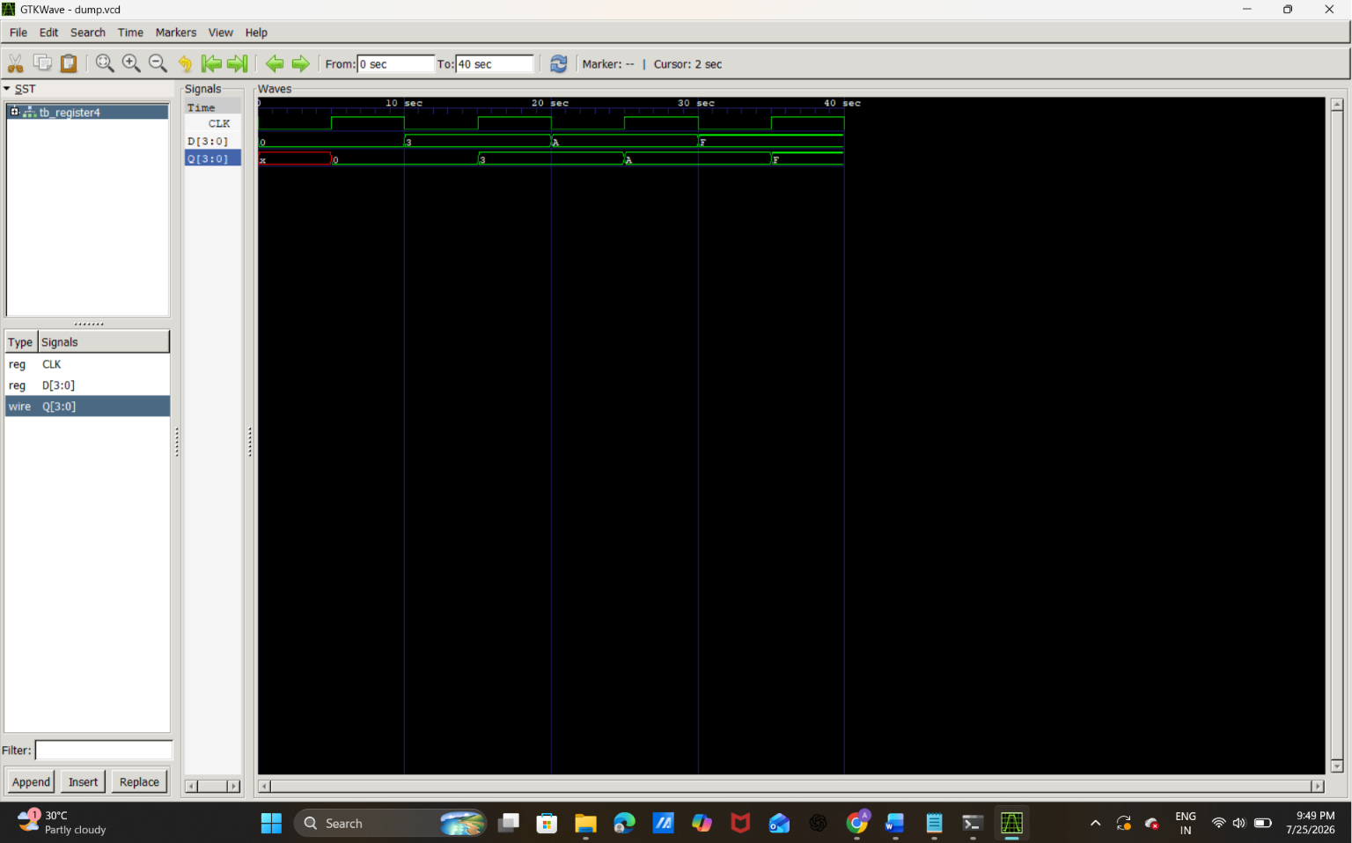
Signals
- CLK → Clock signal
- D[3:0] → 4-bit input
- Q[3:0] → 4-bit output

Waveform Explanation
Initially:
CLK = 0
D = 0
Q = X
- Q = X (red) means the register is uninitialized because no clock edge has occurred yet.

First Rising Edge (≈5 ns)
D = 0
Clock rises from 0 → 1.
Therefore,
Q = 0
The register stores the value 0000.

Second Rising Edge (≈15 ns)
Before the clock edge,
D = 3
Binary:
3 = 0011
At the positive edge,
Q = 3
The register stores 0011.

Third Rising Edge (≈25 ns)
Input changes to
D = A
Hexadecimal:
A = 1010
At the next rising edge,
Q = A
The register stores 1010.

Fourth Rising Edge (≈35 ns)
Input becomes
D = F
Hexadecimal:
F = 1111
After the rising edge,
Q = F
The register stores 1111.

Observation
The important thing to notice is:
- When D changes, Q does not change immediately.
- Q changes only at the rising edge of CLK.
This is exactly how a register works.

Timing Table
Clock Edge | D (Input) | Q (Output)
Initial | 0 | X (Unknown)
1st Rising Edge | 0 | 0
2nd Rising Edge | 3 | 3
3rd Rising Edge | A | A
4th Rising Edge | F | F

Conclusion
The simulation verifies the correct operation of the 4-bit register. The output Q stores the value of the input D only at the positive edge of the clock and retains the stored value until the next rising edge. The initial unknown state (X) is due to the register not being initialized before the first clock edge. The waveform confirms that the register correctly captures the input values 0, 3, A, and F on successive clock pulses.

4-bit Binary Counter simulation
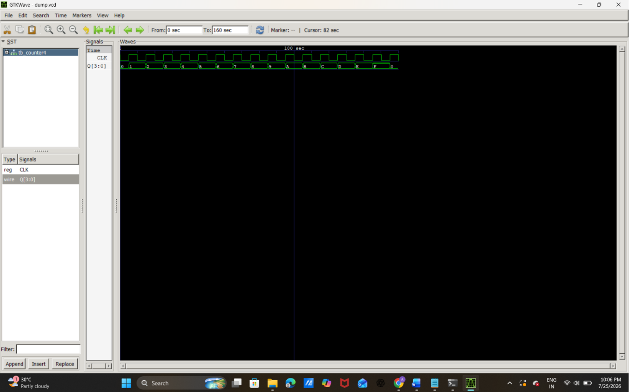
Signals Used
Signal | Description
CLK | Clock Input
Q[3:0] | 4-bit Counter Output

Initial State
At the beginning,
CLK = 0
Q = 0000
The counter starts from 0.

First Rising Edge
When the first positive edge of the clock occurs,
Q = 0001
The counter increments from 0 to 1.

Second Rising Edge
Q = 0010
Counter becomes 2.

Third Rising Edge
Q = 0011
Counter becomes 3.

Counting Sequence
The counter continues increasing on every positive clock edge.
Decimal | Binary | GTKWave Display
0 | 0000 | 0
1 | 0001 | 1
2 | 0010 | 2
3 | 0011 | 3
4 | 0100 | 4
5 | 0101 | 5
6 | 0110 | 6
7 | 0111 | 7
8 | 1000 | 8
9 | 1001 | 9
10 | 1010 | A
11 | 1011 | B
12 | 1100 | C
13 | 1101 | D
14 | 1110 | E
15 | 1111 | F
Notice that GTKWave displays values greater than 9 in hexadecimal:
- A = 10
- B = 11
- C = 12
- D = 13
- E = 14
- F = 15

Counter Overflow
After reaching
1111 (15)
the next positive clock edge causes
1111 → 0000
The counter automatically starts counting from 0 again.
This is because a 4-bit counter can represent only 16 values (0–15).

Observation
- The counter increments by one on every positive edge of the clock.
- Between clock edges, the output remains unchanged.
- The output follows the sequence 0 → 1 → 2 → … → 15.
- After reaching 15, it wraps around to 0 and continues counting.
- The waveform confirms the correct operation of the 4-bit synchronous binary counter.

Conclusion
The simulation successfully verifies the operation of the 4-bit binary counter. The output increments by one at every positive edge of the clock and counts sequentially from 0 to 15. After reaching the maximum value (1111), the counter automatically resets to 0000 and repeats the counting sequence. The GTKWave waveform confirms the expected behavior of a synchronous 4-bit counter.

